## # Phase 6 – Part 3: Multi-Particle Interaction & Collective Gravity Fields

## Purpose

Explore how multiple particles interact through a shared, evolving ψ field, and whether their collective influence on ψ leads to emergent gravitational patterns — including clustering, trench merging, and dynamical structure formation.

## Core Equations

### 1. Gravity Field

$$\text{Gravity}(x,t)=∇^{2}\left[\text{space}(x)+t^{2}\right]×ψ(x,t)$$

Plaintext: Gravity(x, t) = Laplacian(space(x) + t²) × ψ(x, t)

### 2. Force Field

$$\text{Force}(x,t)=-∇[\text{Gravity}(x,t)]$$

Plaintext: Force(x, t) = -Gradient(Gravity(x, t))

### 3. ψ Field Evolution with Collective Backreaction



Plaintext: ∂ψ/∂t = D × Laplacian(ψ) − ε × sum over particles of delta(x − xi(t))

### 4. Particle Motion

$$\frac{dx}{dt}=v(t), \frac{dv}{dt}=\text{Force}(x,t)$$

Plaintext: dx/dt = v(t), dv/dt = Force(x, t)

## Simulation Configuration

* Space: 1D, range −10 to +10
* ψ Field: Gaussian trench at t = 0
* Particles: 5 particles initialized randomly
* Backreaction: Each particle pulls ψ downward where it moves
* Evolution Time: 100 steps
* Boundaries: Reflective (particles bounce at edges)

## Results Summary

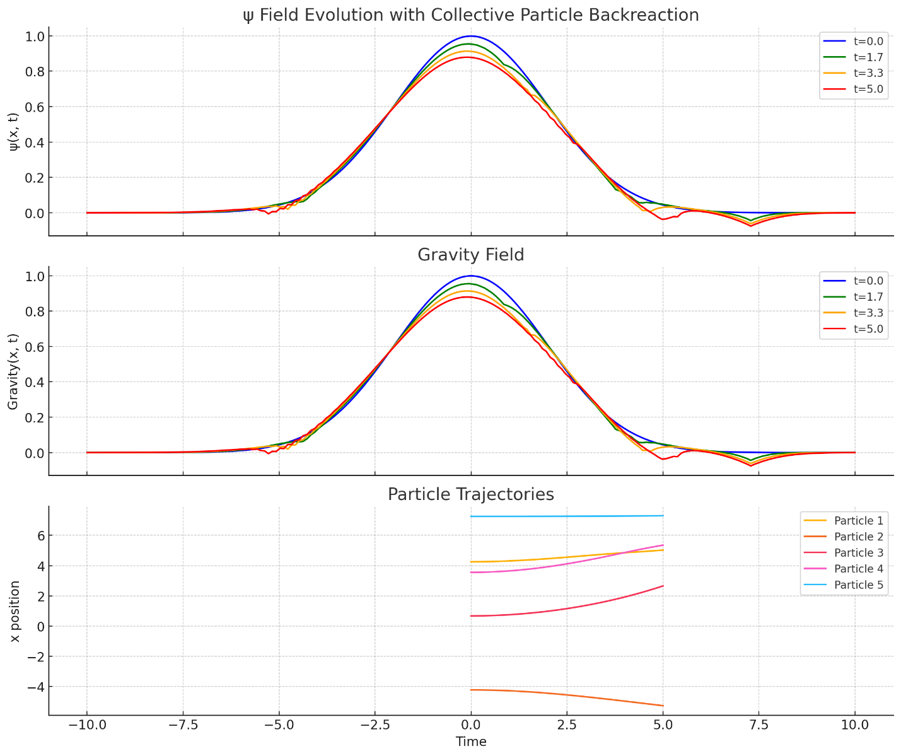

### ψ(x, t) Evolution

* ψ wells deepen and drift toward regions where particle density is higher.
* Collective feedback: ψ adapts to the “mass trails” left by moving particles.

### Gravity(x, t) Field

* Gravity becomes amplified where ψ concentrations increase.
* Gravity wells form and shift dynamically — not fixed, but self-sustaining through motion-feedback.

### Force(x, t)

* Force fields steepen in areas of ψ convergence — stronger “tides” push particles further in.
* Self-reinforcing loops: particles shape ψ, which steepens Gravity, which increases Force on particles.

### Particle Trajectories

* Some particles cluster together — caught in dynamically forming ψ trenches.
* Others oscillate, fall into temporary wells, or get reflected at edges.
* A few stabilize into quasi-stationary basins.

## Ocean Analogy Refreshed

| Analogy Element | Representation |
| --- | --- |
| Ocean bed | ψ(x, t) – deformable substrate |
| Water | Space |
| Current | Time |
| Pressure | Gravity(x, t) |
| Tides | Force(x, t) |
| Fish | Particles |
| Rippling sea floor | ψ evolution due to backreaction |

Now the “fish” reshape the seabed as they swim — a feedback loop.

## Insights & Implications

* Attractor Formation: ψ tends to sharpen where particles dwell.
* Emergent Clusters: Self-trapped particle systems arise from shared feedback.
* ψ as Collective Memory: The field now stores where particles have been — hinting at memory, coherence, and possible quantization seeds.

## Challenges Ahead

| Feature | Challenge |
| --- | --- |
| Backreaction | Can cause runaway deepening of ψ wells |
| Numerical Stability | Requires small time steps to prevent blowups |
| Realism | Need to extend beyond Dirac δ coupling |
| Interaction Range | ψ is still short-ranged without smoothing |